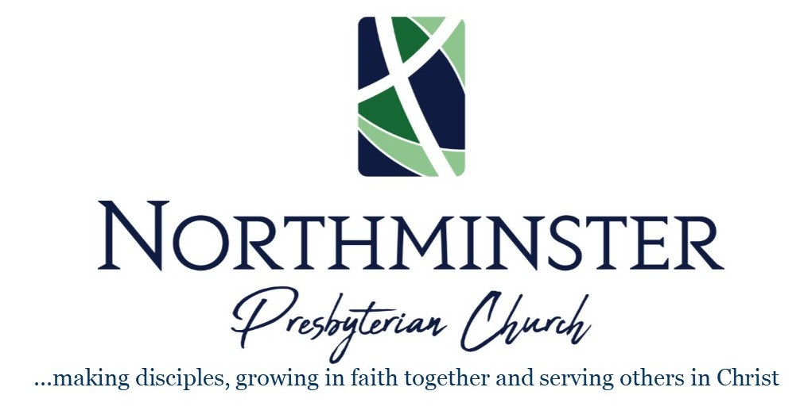

March 17, 2023 Fifth Sunday of Lent 10:30am

GATHERING
Chimes

Welcome

Prelude

Opening Prayer

Call to Worship – based on Psalm 23

The Eternal is our shepherd, caring for us, always.
God provides rest in rich, green fields
beside streams of refreshing water.
The Eternal makes us whole again,
steering us off worn, hard paths
to roads where truth and righteousness echo His name.
Even in the unending shadows of death’s darkness,
we are not overcome by fear.
Because You are with us in those dark moments,
near with Your protection and guidance.
You spread out a table before us,
provisions in the midst of attack from any enemies.
Certainly Your faithful protection and loving provision will pursue us
wherever we go, always, everywhere.
We will always be with the Eternal,
in Your house forever.

*Hymn #803 My Shepherd Will Supply My Need

My shepherd will supply my need; Jehovah is his name.
In pastures fresh he makes me feed, beside the living stream.
He brings my wandering spirit back when I forsake his ways,
and leads me, for his mercy's sake, in paths of truth and grace.
When I walk through the shades of death your presence is my stay;
one word of your supporting breath drives all my fears away.
Your hand, in sight of all my foes, does still my table spread;
my cup with blessings overflows; your oil anoints my head.
The sure provisions of my God attend me all my days;
O may your house be my abode, and all my work be praise.
There would I find a settled rest, while others go and come;
no more a stranger, or a guest, but like a child at home.

CONFESSING

Call to Confession

Prayers of Confession

Almighty God,
your Son came into the world
to free us all from sin and death
and to shepherd us back to your care.

Breathe upon us with the power of your Spirit,
that we may be raised to new life in Christ,
and serve you in holiness and righteousness all our days;
through the same Jesus Christ, our Lord,
in whose saving name we now pray …

Assurance of Forgiveness

Remembering our Baptisms

Scripture — Philippians 3:13-14

Response to Forgiveness #175 Seek Ye First

Seek ye first the kingdom of God and its righteousness,
And all these things shall be added unto you. Allelu, alleluia!

*Passing the Peace

Announcements and Invitations

Gathering of our Offerings

Offertory Music

*Response — Doxology #606

Praise God from whom all blessings flow Praise God all creatures here below
Praise God for all that love has done Creator, Christ, and Spirit one. Amen

Prayers of Intercession, Lord’s Prayer
Our Father, Who art in Heaven, Hallowed by Thy name, Thy Kingdome Come, Thy will be done, on earth as it is in heaven. Give us this day our daily bread. And forgive us our debts as we forgive our debtors. And lead us not into temptation but deliver us from evil, for Thine is the Kingdom, and the power and the glory, forever. Amen.

LISTENING

Scripture – Psalm 23

Hymn #451 (remain seated) Open My Eyes, That I May See

Open my eyes, that I may see glimpses of truth thou hast for me.
Place in my hands the wonderful key that shall unclasp and set me free.
Silently now I wait for thee, ready, my God, thy will to see.
Open my eyes; illumine me, Spirit divine!
Open my ears, that I may hear voices of truth thou sendest clear.
And while the wave notes fall on my ear, everything false will disappear.
Silently now I wait for thee, ready, my God, thy will to see.
Open my ears; illumine me, Spirit divine!
Open my mouth, and let me bear gladly the warm truth everywhere.
Open my heart, and let me prepare love with thy children thus to share.
Silently now I wait for thee, ready, my God, thy will to see.
Open my heart; illumine me, Spirit divine!

Scripture – John 10:1-18

Sermon – Jesus, the Good Shepherd Dr. Michael Parker, guest preacher

DEPARTING

*Hymn #697 Take My Life

Take my life and let it be consecrated, Lord, to thee;
take my moments and my days; let them flow in ceaseless praise;
let them flow in ceaseless praise.
Take my hands and let them move at the impulse of thy love;
take my feet and let them be swift and beautiful for thee,
swift and beautiful for thee.
Take my voice and let me sing always, only, for my King;
take my lips and let them be filled with messages from thee,
filled with messages from thee.
Take my sliver and my gold; not a mite would I withhold;
take my intellect and use every power as thou shalt choose,
every power as thou shalt choose.
Take my will and make it thine; it shall be no longer mine.
Take my heart, it is thine own; it shall be thy royal throne,
it shall be thy royal throne.
Take my love; my Lord, I pour at thy feet its treasure store;
take myself and I will be ever, only, all for thee,
ever, only, all for thee.

*Charge and Benediction

*Sung Response
May the road rise to meet you, may the wind blow at your back. May the sun shine warmly on your face, may the rain fall softly on your fields. And until we meet again, until we meet again, may God hold you in the palm of His hand. Amen

Postlude

Information & Announcements

Welcome to our guests!
Whether you are sharing in the worship of God with us for the first time, visiting with family or friends, or returning for a visit to your home church, we welcome you today in the name of Jesus. Please share some contact information with us so we can follow up with you and make a place for you in our weekly fellowship. You may email our church office at admin@northminstermacon.org.

Welcome Guest Preacher, Dr. Michael Parker
We are delighted to welcome to our pulpit today the Rev. Dr. Michael Parker, a PCUSA pastor who served as a missionary and professor of church history for many years in Sudan, Rwanda, and Egypt. Most recently, he was the director of graduate studies at the Evangelical Theological Seminary in Cairo, Egypt, from 2012-2020. Dr. Parker has recently published a biography of the late Dr. Kenneth Bailey, whose studies on the birth of Jesus and the Lord’s Prayer we have recently reviewed as a congregation. Michael is also the author of five previous books, including The Kingdom of Character: The Student Volunteer Movement for Foreign Missions, 1886–1926 (2008).

Prayer Concerns
If you have a need or a request for prayer, please contact the church office.
Current Member Concerns: Ann R. Smith; Jane Prentice; Ann Hall; Jane Ebey; Evelyn Clark; Nancy Miles; Annette Hutto - Current Friends and Family Concerns: Margaret Yawn; Donna Carole Kitchens; Joel Jones; Nelda Crow; John & Louise Sallstrom - Military Personnel Prayer List: Austin Riley; Joshua Sulkers; Isaac Falkenstine (Bonnie Diboll’s grandson); Nicholas Sanchez (Kathy McCord’s godson); James Watwood; Dawson Everett (Gwen Kitchens’ great-nephew)

Lenten Bible Study – Wednesdays through March 27
Join us for a 7-week Lenten series featuring videos from the late Dr. Kenneth Bailey on Jesus’ instructions for prayer (Matthew 6) and Paul’s love language (1 Corinthians 13). Women can meet Wednesday mornings at 10am in the community room with discussion led by Jeanne Roddenberry and all are invited to attend Wednesday evenings at 7pm via Zoom with discussion led by Ralph Hawkins.

Children’s Sunday School – seeking donations
All Elementary children (K4 through 5th grade) are invited to attend Sunday School at 10:00_{AM}. We'll have a quick lesson with a craft and a morning snack. All children will join their parents for the worship service at 10:30. Our children’s ministry would also appreciate donations of glue sticks, crayons, tape, scissors, markers, or other craft supplies. Please bring any of your donated items to church any Sunday morning.

Easter Lilies
Every year, Northminster congregants help fill our sanctuary with Easter Lilies on Easter Sunday. These flowers represent beautiful memories of loved ones who have died. Please see your blue sheet for information about having a lily for your loved one(s). After worship, lilies can be taken home or taken to someone you know who could appreciate their beauty. Cost is $12 each; checks can be made payable to the church with “lilies” in the memo line.

Maundy Thursday Service – March 28
We will hold our annual Maundy Thursday worship service March 28th at 6PM.

5th Sunday Fellowship Meal
Typically, we share lunch together after worship on the last Sunday of a month with five Sundays. Since this month holds the same, but falls on Easter, we will share breakfast at 9AM instead. Sunday School will not be held. Please let us know on your blue response sheet if you plan to attend.

Easter Egg Hunt – March 31st at 10AM
All NPC kids – bring your Easter basket Easter morning! As the adults are winding down breakfast and the kids have likely finished, we invite all children to participate in an Easter Egg Hunt around 10:00. If you are willing to donate towards the purchase of the eggs and candy, please notate “Egg Hunt” on your donation. If you are willing to help prepare for the hunt Sunday morning, please let Donna Shuford or Chloe Napier know.

PCUSA Special Offerings – One Great Hour of Sharing
Millions of people lack asset to sustainable food sources, clean water, sanitation, education and opportunity. The three programs supported by One Great Hour of Sharing-Presbyterian Disaster Assistance, the Presbyterian Hunger Program, and Self Development of People-all work in different ways to serve individuals and communities in need. From initial disaster response to ongoing community development. Their work fits together to provide people with safety, sustenance, and hope. This offering will be collected Easter Sunday, March 31st.

Choir – Wednesdays at 7_{PM}
We are so thankful for our wonderful choir, under the direction of music minister Gunner Chancey, who fill our sanctuary with prayerful praise through song every Sunday. We’d love to see YOU join them in the loft. Choir practices are held each Wednesday at 7_{PM} in the choir room downstairs (entrance at the back of the building near the playground) and warm-up at 10_{AM} Sunday morning before worship.

Sunday Study at 9_{AM}
Join us for Sunday Study at 9_{AM} in the fellowship hall. Today began a 6-week series led by Dr. Bryan Whitfield. Bryan is teaching from the book Lent for Everyone Year B, Mark by NT Wright. A light continental breakfast is provided.

NORTHMINSTER PRESBYTERIAN CHURCH
Our calling at Northminster is to make disciples, to grow in faith together, and to serve others in Christ.

CONGREGATION: Ministers of the Good News; SESSION of Ruling Elders: Kari Alderman; Mark Brown; Jeff Denny; Barbara Fatkin;
Nita McCord; Michael Napier; Donna Shuford; Amanda Smith; Minor Vernon; Gail Walker
RALPH HAWKINS, Pastor and Teaching Elder PAUL EVANS, Parish Associate GUNNER CHANCEY, Director of Music
KAREN JONES, Clerk of Session JENNIFER WHITEHEAD, Ministry Assistant

Office hours this week: 9:00-3:00 Tuesday-Thursday; 7:00-1:00 Sunday; Jennifer Cell: 478-318-7911

All rights reserved, License #1244003

WWW.NORTHMINSTERMACON.ORG 565WIMBISH RD. MACON, GA 31210

